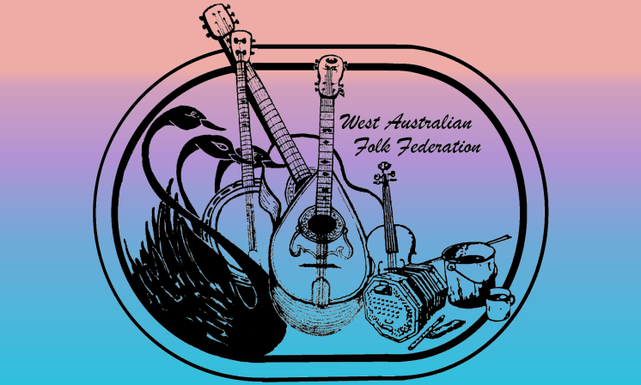
WAFF Membership Form
The options for payment are:
Electronic Funds Transfer (details below)
Cheque made out to The West Australian Folk Federation
Cash or card payment at Wanneroo Folk Club.
For all payment options please fill out this form and forward it to the WAFF to provide or update your details (WAFF details, email and cost options are shown below)
Thank you for your subscription, we look forward to your continued support.
Personal Details: Mem. No (if renewing)
Name: Spouse/Partner: .
Address: P/Code:
Home: Mobile: Work: .
Email (please print clearly):
Web page:
Occupation/Special Talents:
Would you be willing to donate your time or services to WAFF occasionally?
Are you a performer? , do you wish your details passed on to people making enquiries
Info you are happy to have passed on:
Interests: Song - , Music - , Poetry/yarns - , Dance - ,
Annual Subscription Rates
1 year Membership: Single $20 , Family $30 , Affiliate $40
3 year Membership: Single $60 , Family $90 , Affiliate $120

Donations to WAFF assist in running events & promoting Folk in WA.
If you wish to include a donation just add it to the total and tick this box
My payment option is: EFT transfer Cash Cheque amount: $
EFT Details: BSB: 086-488 Account No.: 21-602-5207
Use your name as a reference/description so that we can identify the deposit.
Please fill in the form
(fill in the boxes, save and email to the address below so we can process it faster)

WA Folk Federation, PO Box 328, Inglewood, WA 6932
ABN: 23 052 531 652
Email: wafolk@hotmail.com Web: www.wafolk.org.au

