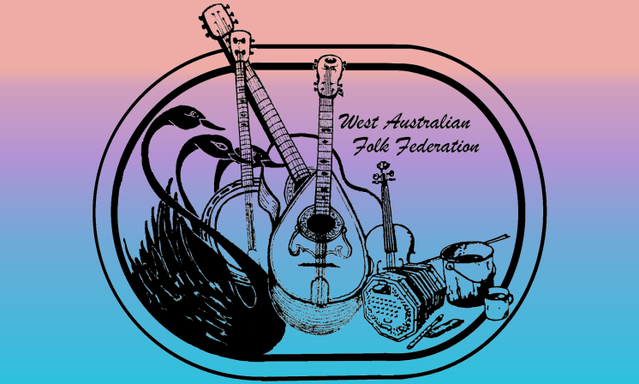**West Australia Folk Federation  
Membership Form**

Use this form for New or Renewing memberships  
The options for payment are:  
Electronic Funds Transfer (details below)  
Cheque, Cash or card payment at Wanneroo Folk Club or Swan Acoustic (*card payments have a surcharge*)

For all payment options please fill out this form and email it to the WAFF to provide or update your details (WAFF details, email and cost options are shown below)

Thank you for your subscription, we look forward to your continued support.

Personal Details: Mem. No (if renewing)

Name:       Spouse/Partner:      .

Address:       P/Code:

🕿 Home:       Mobile:       Work:      .

Email (please print clearly):

Web page:

Occupation/Special Talents:

Would you be willing to donate your time or services to WAFF occasionally?

Are you a performer? , do you wish your details passed on to people making enquiries

Info you are happy to have passed on:

Interests: Song - , Music - , Poetry/yarns - , Dance - ,

Annual Subscription Rates

1 year Membership: Single $20 , Family $30 , Affiliate $40

3 year Membership: Single $60 , Family $90 , Affiliate $120

Donations to WAFF assist in running events & promoting Folk in WA.

If you wish to include a donation just add it to the total and tick this box

My payment option is: EFT transfer  Cash  Cheque  amount: $

EFT Details for Internet Bank: BSB: 086-006 Account No.: 523 729 415   
Acct Name: West Australian Folk Federation  
Please note this is a new bank account.   
You may need to amend or delete the entry in your Netbank address list if you have used EFT before.  
*Reference/description so that we can identify the deposit <Your name> membership.*

Please fill in the form   
(fill in the boxes, save it and email it to the email address below   
so we can process it faster)

**West Australian Folk Federation Inc,**We no longer have a Mail Box but you can email us **ABN: 72 737 533 655**

**Email:** [**wafolk@hotmail.com**](mailto:wafolk@hotmail.com) **Web:** [**www.wafolk.org.au**](http://www.wafolk.org.au)